Anaconda / tensorflow / keras版本問題

RuntimeError: `get_session` is not available when using TensorFlow 2.0.

ImportError: cannot import name 'abs'

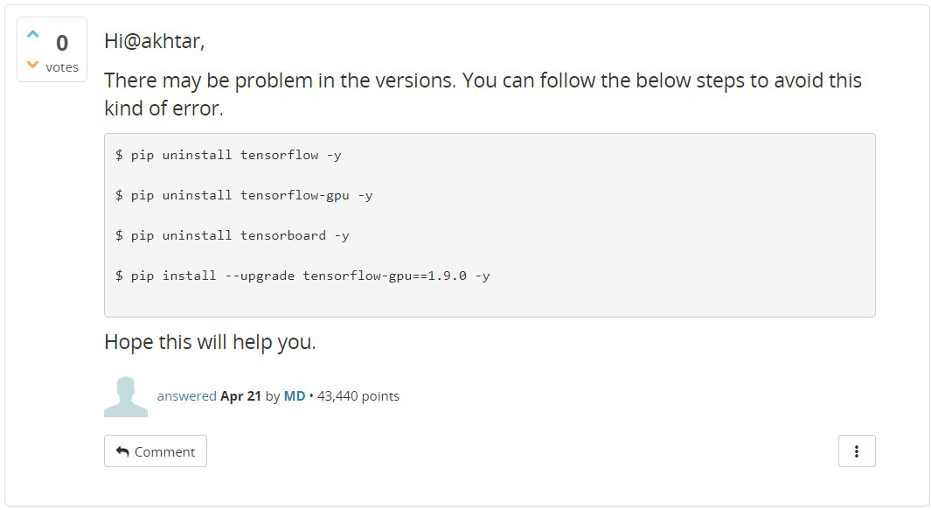

$ pip uninstall tensorflow -y

$ pip uninstall tensorflow-gpu -y

$ pip uninstall tensorboard -y

$ pip install --upgrade tensorflow-gpu==1.9.0 –y (系統找不到該版本)

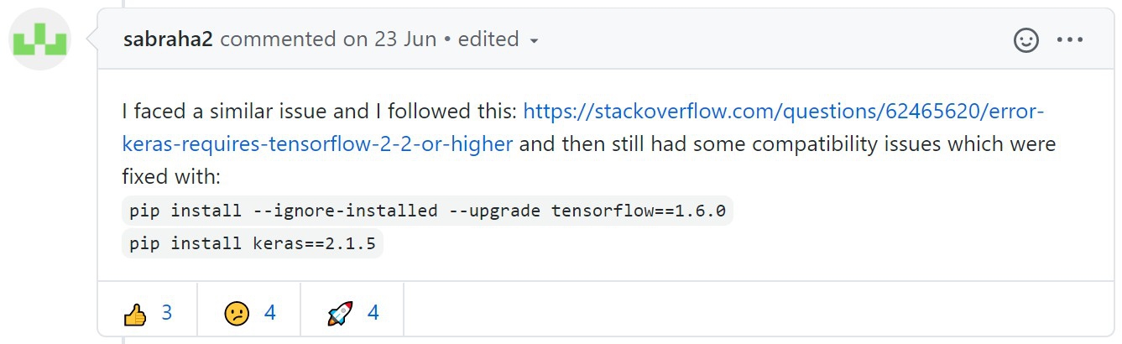

pip install --ignore-installed --upgrade tensorflow==1.6.0

pip install keras==2.1.5